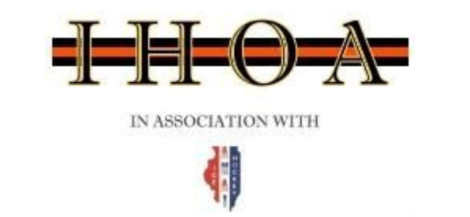
Monday August 8, 2022@ 7:00pm
Via Zoom

Board Members in Attendance (*denotes absence)

Brad Baumruck | Todd Permut | Scott Gaffney
John Dunne | Anthony Fiorito | Mark Biako
Erika Greenen | Brian Fisher | Joe Guzzardi*
Steve Rickard | Carl Sassolino | Geoff Schlender
Craig Welker* | Brett Straley | Dave Zeloudek

Referee-in-Chief: Brad Baumruck

District RIC: Tim Richter*

Call to order- 7:02 by Rickard

AGENDA

- Approve June Meeting Minutes- Motion- Straley, Second Fiorito

- IHOA update/September Board Meeting- Baumruck
- 655 officials signed up for IHOA
  - 299 level 1
  - 147 level 2
  - 115 level 3
  - 94 level 4

- Seminars/Registration- Fiorito/Fisher

- Presidents Meetings- Rickard
- Let Brad and Steve know if you are interested in attending

- Mentors/Instructor Jackets and Polos- Sassolino
- Everything is in, XL polos are going to be coming in at the end of the month
- Mentor meeting is being sent out soon

- ADP- Baumruck/Straley
- Once secure ice a tryout date will be sent.
- First tournament September 16-18th

- AHAI news- Dunne
- A good amount of password resets have been coming through for new officials

Future Events: Next board meeting: September- in person
Adjournment: 8:02 by Sassolino, Second by Fiorito
Minutes taken by: Greenen

