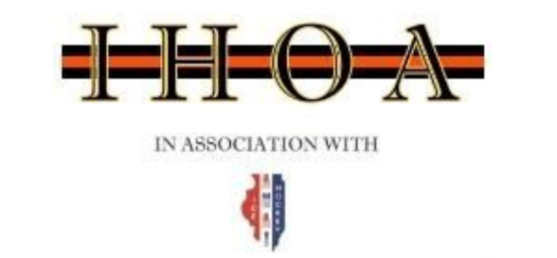
Monday, September 12, 2022@ 7:00pm
Via Zoom

Board Members in Attendance (*denotes absence)

Brad Baumruck | Todd Permut | Scott Gaffney
John Dunne* | Anthony Fiorito | Mark Bialko
Erika Greenen* | Brian Fisher | Joe Guzzardi
Steve Rickard | Carl Sassolino | Geoff Schlender
Craig Welker | Brett Straley | Dave Zaloudek

Referee-in-Chief: Brad Baumruck

District RIC: Tim Richter*

Call to order: 7:02PM by Rickard

AGENDA

- Approve August Meeting Minutes- Motion Fiorito - Second Permut
- Approve August Financials- Motion Baumruck - Second Bialko
- Seminar and Registration Update (Fisher, Fiorito, Baumruck)
  - IHOA Registration Numbers: 983 total
    - Level 1 458
    - Level 2 201
    - Level 3 184
    - Level 4 140
  - Overall ~1300 with many Illinois officials registering with only USA Hockey
    - Email to correct lapse in IHOA registration sent to officials in this category
  - New ideas around seminar participation were introduced with an eye on the next registration period (’23 - ’24)
  - Fiorito has held one Zoom event focused on the AHAI assigning site to help new Level 1 officials become more familiar
    - Response and participation, excellent
    - Volunteers needed to continue these sessions
  - Need for additional certified instructors

- IHOA Promotional Material
  - In rink recruitment signage planning
  - Multiple versions introduced
  - Quote for signage being pursued
  - Timing TBD based on pricing, budget, and funding source
  - IHOA website refresh slated for early 2023

- ADP Update (Baumruck, Straley)
  - 3-Official System Zoom call on 9/7/22 Lead by Straley and Pacocha
    - 35 Attendees
    - Prep for the Wheaton West Tournament
    - Introduction for new participants within the ADP Program for ’22 - ‘23
    - Possible Blackhawks partnership for new IHOA Officials through Blackhawks Amateur Hockey Department
  - Wheaton West Tournament Re-Cap
    - Officials did well
    - Opportunities areas were noted
    - Several returning ADP participants have shown tremendous growth

- Mentor Program Update (Sassolino)
  - First Mentor meeting occurred on 9/8/22
  - Next Mentor meeting is on 9/13/22
  - Carl has requested the ability to load games into the AHAI assigning site

- PED Update (Straley)
  - No current PEDs

- AHAI Update (Rickard for Dunne)
  - USA Hockey is having issues processing SafeSport certifications
  - IT issues continue to exist at USA Hockey with various registration functions

Future Events: Next board meeting: October 10th – location is still TDB
Adjournment: 8:19pm by Sassolino, Second by Fiorito
Minutes taken by: Straley

